### Bug 1

Bug Code:

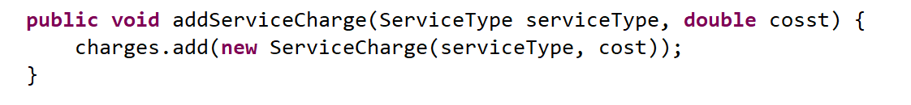

Bug test results:

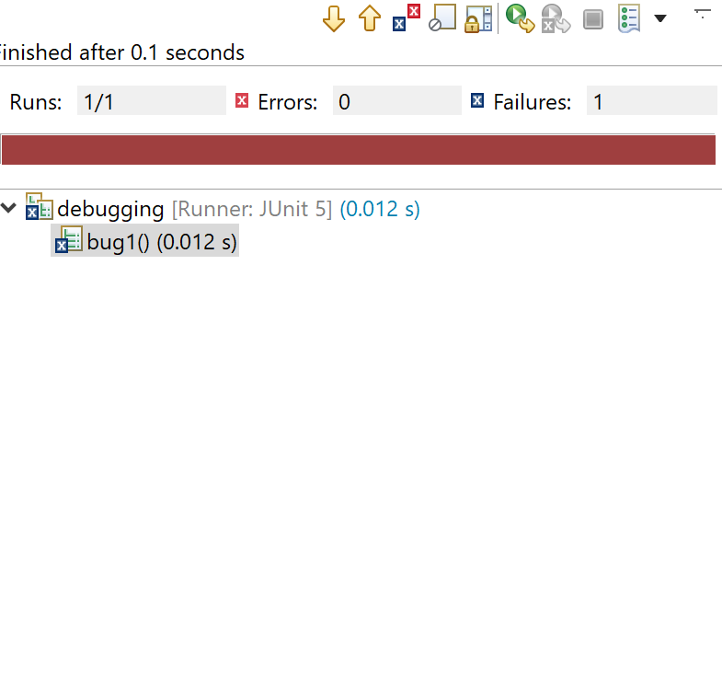

Repaired Code:

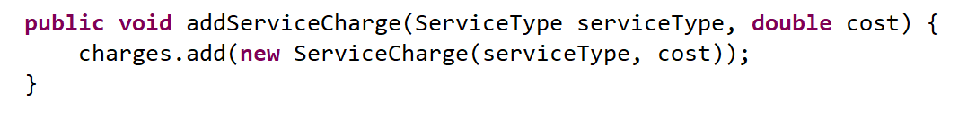

Repaired Results:

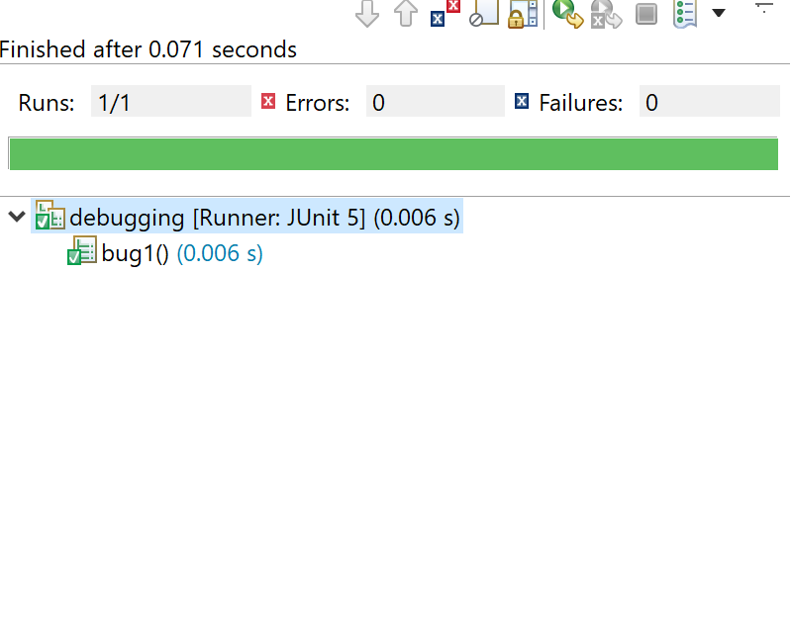

### Bug 2

Bug Code

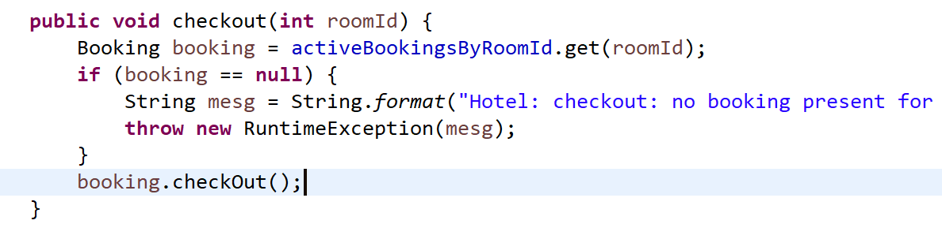

Bug results:

Repaired Code:

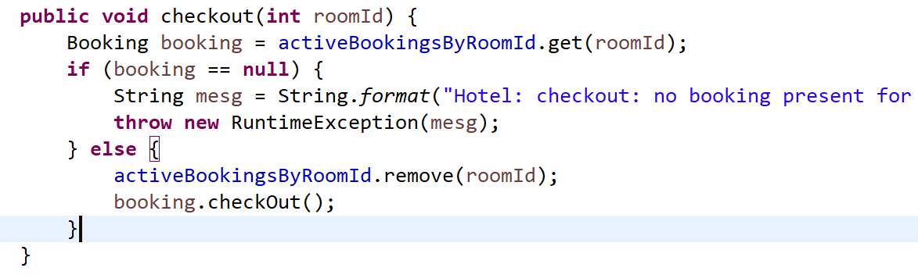

Repaired Results: